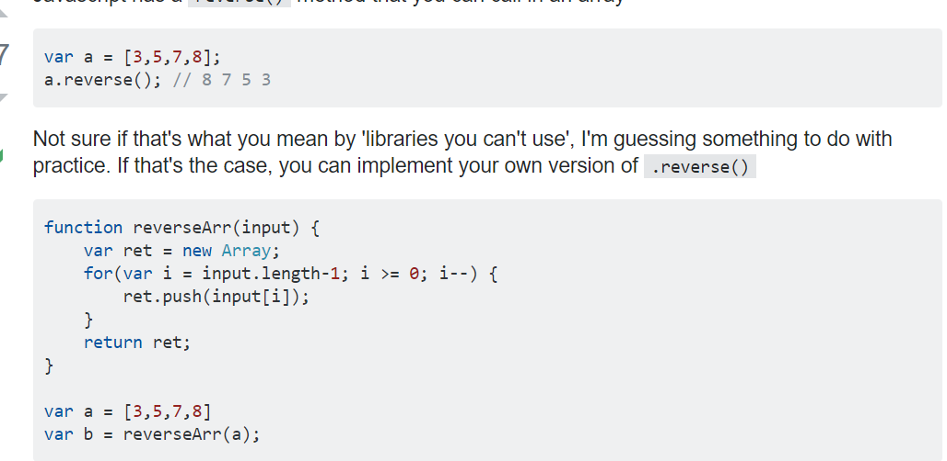

Find Second maxi mun number in array

int[] myArray = new int[] { 1, 2, 4, 10, 20, 100 };

var biggest = myArray[0];

var secondMax = myArray[0];

for (var i = 0; i < myArray.Count(); i++)

{

if (myArray[i] > biggest)

{

secondMax = biggest;

biggest = myArray[i];

}

else if (myArray[i] > secondMax && myArray[i] != biggest)

secondMax = myArray[i];

}

Remove Duplicate from array

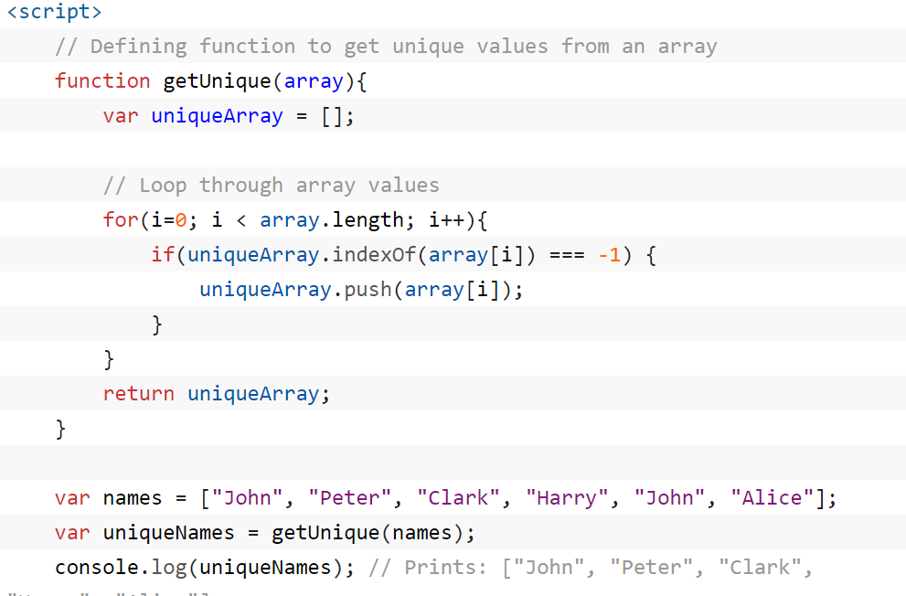

int[] myArray = new int[] { 0, 1, 2, 3, 13, 8, 5 };int largest = int.MinValue;int second = int.MinValue;foreach (int i in myArray){

if (i > largest)

{

second = largest;

largest = i;

}else if (i > second)

second = i;}

System.Console.WriteLine(second);

WITH EmployeesCTE AS

(

   SELECT *, ROW_NUMBER()OVER(PARTITION BY ID ORDER BY ID) AS RowNumber

   FROM Employees

)

DELETE FROM EmployeesCTE WHERE RowNumber > 1

# How to delete elements from an array?

//System.Console.WriteLine(second);

int[] myArray = { 23, 93, 56, 92, 39 };

int size = myArray.Count();

int pos = 2;

for (int i = pos; i < size - 1; i++)

{

myArray[i] = myArray[i + 1];

}